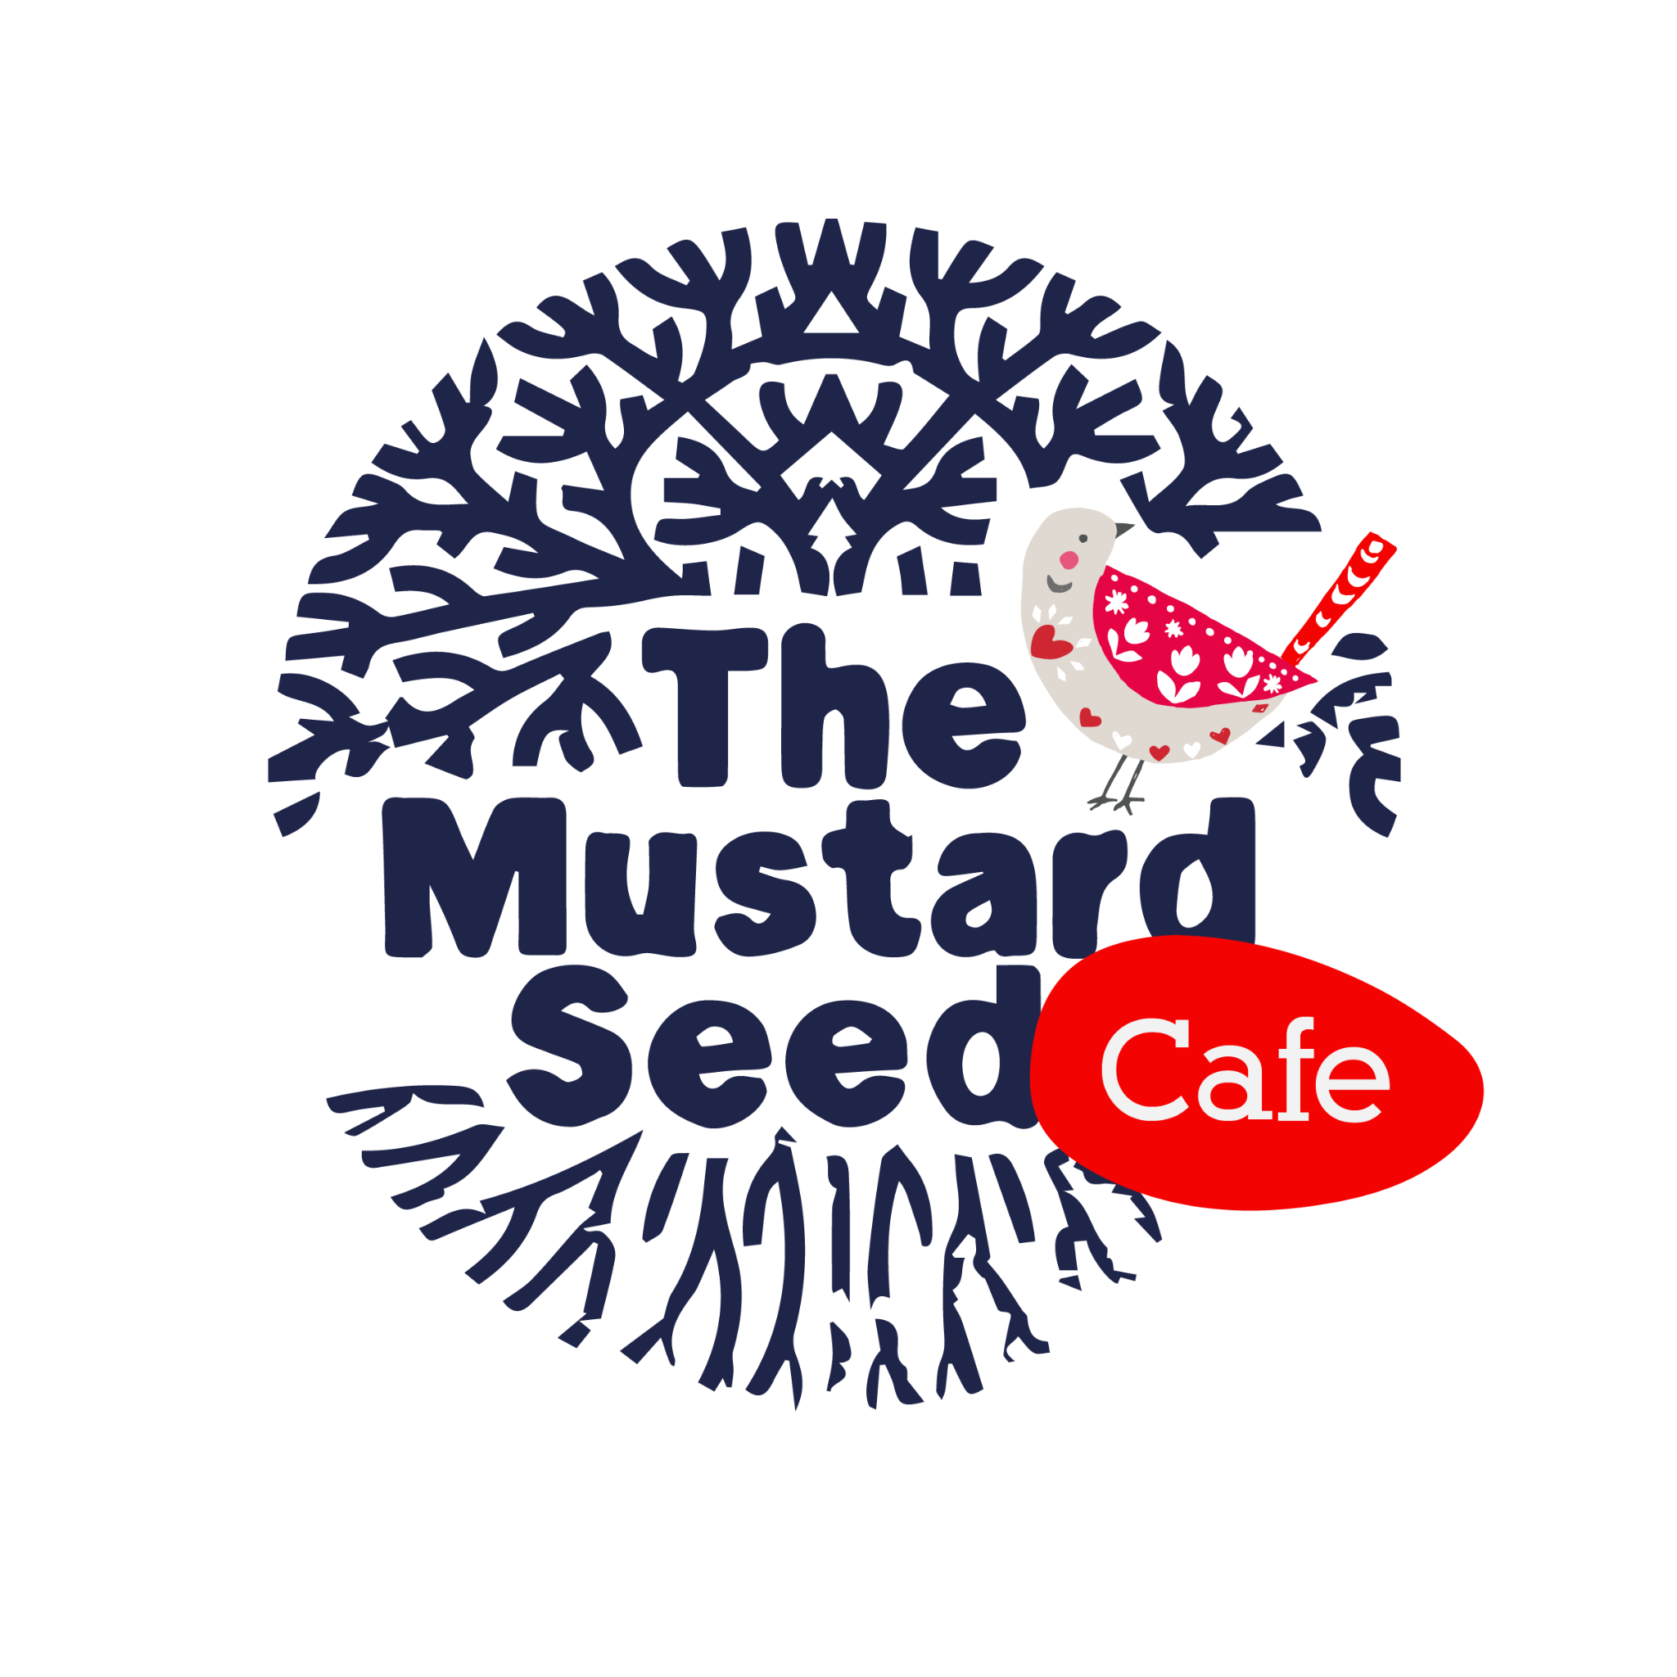

Volunteer…

Be a part and at the heart of what we do!

**Waiver Form**

1. I have read the **Volunteer Manual**, including the Appropriate Conduct Expectations, and I agree to these terms.
2. All Volunteers must report **symptoms** of illness.

I agree to report to the manager before volunteering when I have:

1. Diarrhea
2. Vomiting
3. Jaundice (yellowing of the skin and/or eyes)
4. Sore throat with fever
5. Infected cuts or wounds, or lesions containing pus on the hand, wrist, or any exposed body part, such as boils and infected wounds no matter how small
6. Any other potentially contagious illness
7. All Volunteers must report **diagnosed** illnesses.

I agree to report to the manager before volunteering when I have:

1. Norovirus
2. Salmonella Typhi (typhoid fever)
3. Shigella spp. Infection
4. Hepatitis

_________________________________________ ______________________________________________

Print Name ***clearly*** Signature

__________________________ ___________________________ _____________________

Date Birthday (month & day) T-Shirt Size

_______________________________________ ______________________________________________

Phone # Email ***clearly***

____________________________________________________________________________________________

Address

_______________________________________ ______________ ___________________________

City State Zip

____________________________________________________________________________________________

Emergency Contact Name & Phone #

**Release and Hold Harmless Agreement**

To the best of my knowledge, I am in good physical condition and fully able to participate at the Mustard Seed Café and Garden in El Paso, Texas. I am fully aware of the risks and hazards connected with participation, including physical injury or even death, and hereby elect to voluntarily participate, knowing that the associated physical activity may be hazardous to me and my property. I VOLUNTARILY ASSUME FULL RESPONSIBILITY FOR ANY RISKS OR LOSS, PROPERTY DAMAGE, OR PERSONAL INJURY, INCLUDING DEATH, that may be sustained by me, or loss or damage to property owned by me, as a result of participation.

I hereby RELEASE, WAIVE, DISCHARGE, AND COVENANT NOT TO SUE, the Mustard Seed Café and Garden, the Board of Directors of the Mustard Seed Café, their officers, servants, agents, and employees (hereinafter referred to as RELEASEES) from any and all liability, claims, demands, actions and causes of action whatsoever arising out of or related to any loss, damage, or injury, including death, that may be sustained by me, or to any property belonging to me, while participating, or while on or upon the premises.

It is my expressed intent that this Release and Hold Harmless Agreement shall bind the members of my family and spouse, if I am alive, and my heirs, assigns and personal representative, if I am deceased, and shall be deemed as a RELEASE, WAIVER, DISCHARGE, and COVENANT NOT TO SUE the above named RELEASEES. I hereby further agree that this Release and Hold Harmless Agreement shall be construed in accordance with the laws of the State of Texas.

In signing this release, I acknowledge and represent that I HAVE READ THE FOREGOING Release and Hold Harmless Agreement, UNDERSTAND IT AND SIGN IT VOLUNTARILY as my own free act and deed; no oral representations, statements or inducements, apart from the foregoing written agreements have been made; and I EXECUTE THIS RELEASE FOR FULL, ADEQUATE AND COMPLETE CONSIDERATION FULLY INTENDING TO BE BOUND BY THE MUSTARD SEED CAFÉ.

_______________________________________________________________________

Print Name ***clearly***

_______________________________________________________________________

Signature

________________________________

Date

**Photographic Consent & Release Form**

I, ____________________________________, hereby consent and agree that (Mustard Seed

Cafe and the representatives thereof) has the right to take or use photographs and video clips of

me and/or my property and to use these in any and all media worldwide including online, now or

hereafter known, and for any purpose whatsoever.

I hereby release to the Photographer all rights to exhibit or publish this work in print and

electronic form publicly or privately and to market copies. I waive any rights, claims or interest I

may have to control the use of my likeness in the photographs and agree that any uses

described herein may be made without compensation or additional consideration of me.

I further waive any and all rights to review or approve any uses of the images, any written copy,

or finished product.

I represent that I am at least 18 years of age, have read and understand the foregoing

statement, and am competent to execute this agreement.

Printed Name: ________________________________________ Date: ___________________

Signature: ____________________________________________________________________

Parent/Guardian Name & Signature (if under 18): _____________________________________