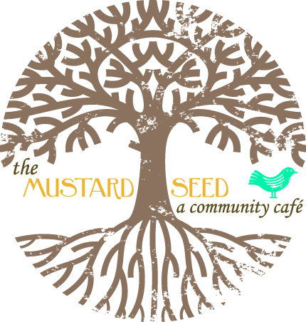

Volunteer… Be a part and at the heart of what we do!

**Minor Volunteer Waiver Form**

I hereby certify that I am the adult parent or guardian of________________________________, a minor child who is ________ years old*, and I consent to his/her participation in a volunteer capacity with the Mustard Seed Café and the Amigos Garden.** In the case that an emergency occurs, I authorize the person in charge to seek qualified medical aid for any injury sustained by my child. I understand that all costs incurred for medical expenses are my responsibility. Also, I understand that my child is expected to act in an appropriate manner, and, if my child does not behave appropriately, I may be required to pick him/her up at the site. Once this document is signed, I understand that the Mustard Seed Café Board of Directors, Staff, and Affiliates are not liable or responsible for any personal injury, loss of property, negligent, willful or intentional act. Additionally, I acknowledge that my son’s/daughter’s participation in volunteering with the Mustard Seed Café, Inc. is entirely voluntary and understand that they are subject to the rules, procedures, and regulations of this organization. Furthermore, I acknowledge that I have read and understand the above statements and that I am of legal age to bind myself to this release waiver.

*Any child under the age of fifteen (15) must be supervised by an accompanying parent/ guardian at all times, and any child under the age of ten (10) may not volunteer in a food service position.

**This includes: a) the Cafe premises or the Amigos Garden at 201 E. Sunset Rd., El Paso, TX 79922; and/or b) any Mustard Seed Café sponsored event.

______________________________________________

Print Name of Parent/Guardian

______________________________________________ __________________

Signature of Parent/Guardian Date

_____________________ _________________________ ________________________________

Volunteer Phone # Email Address

____________________________________________________________________

Emergency Contact Name & Phone #